- Merry Christmas |  |  | Merry Christmas
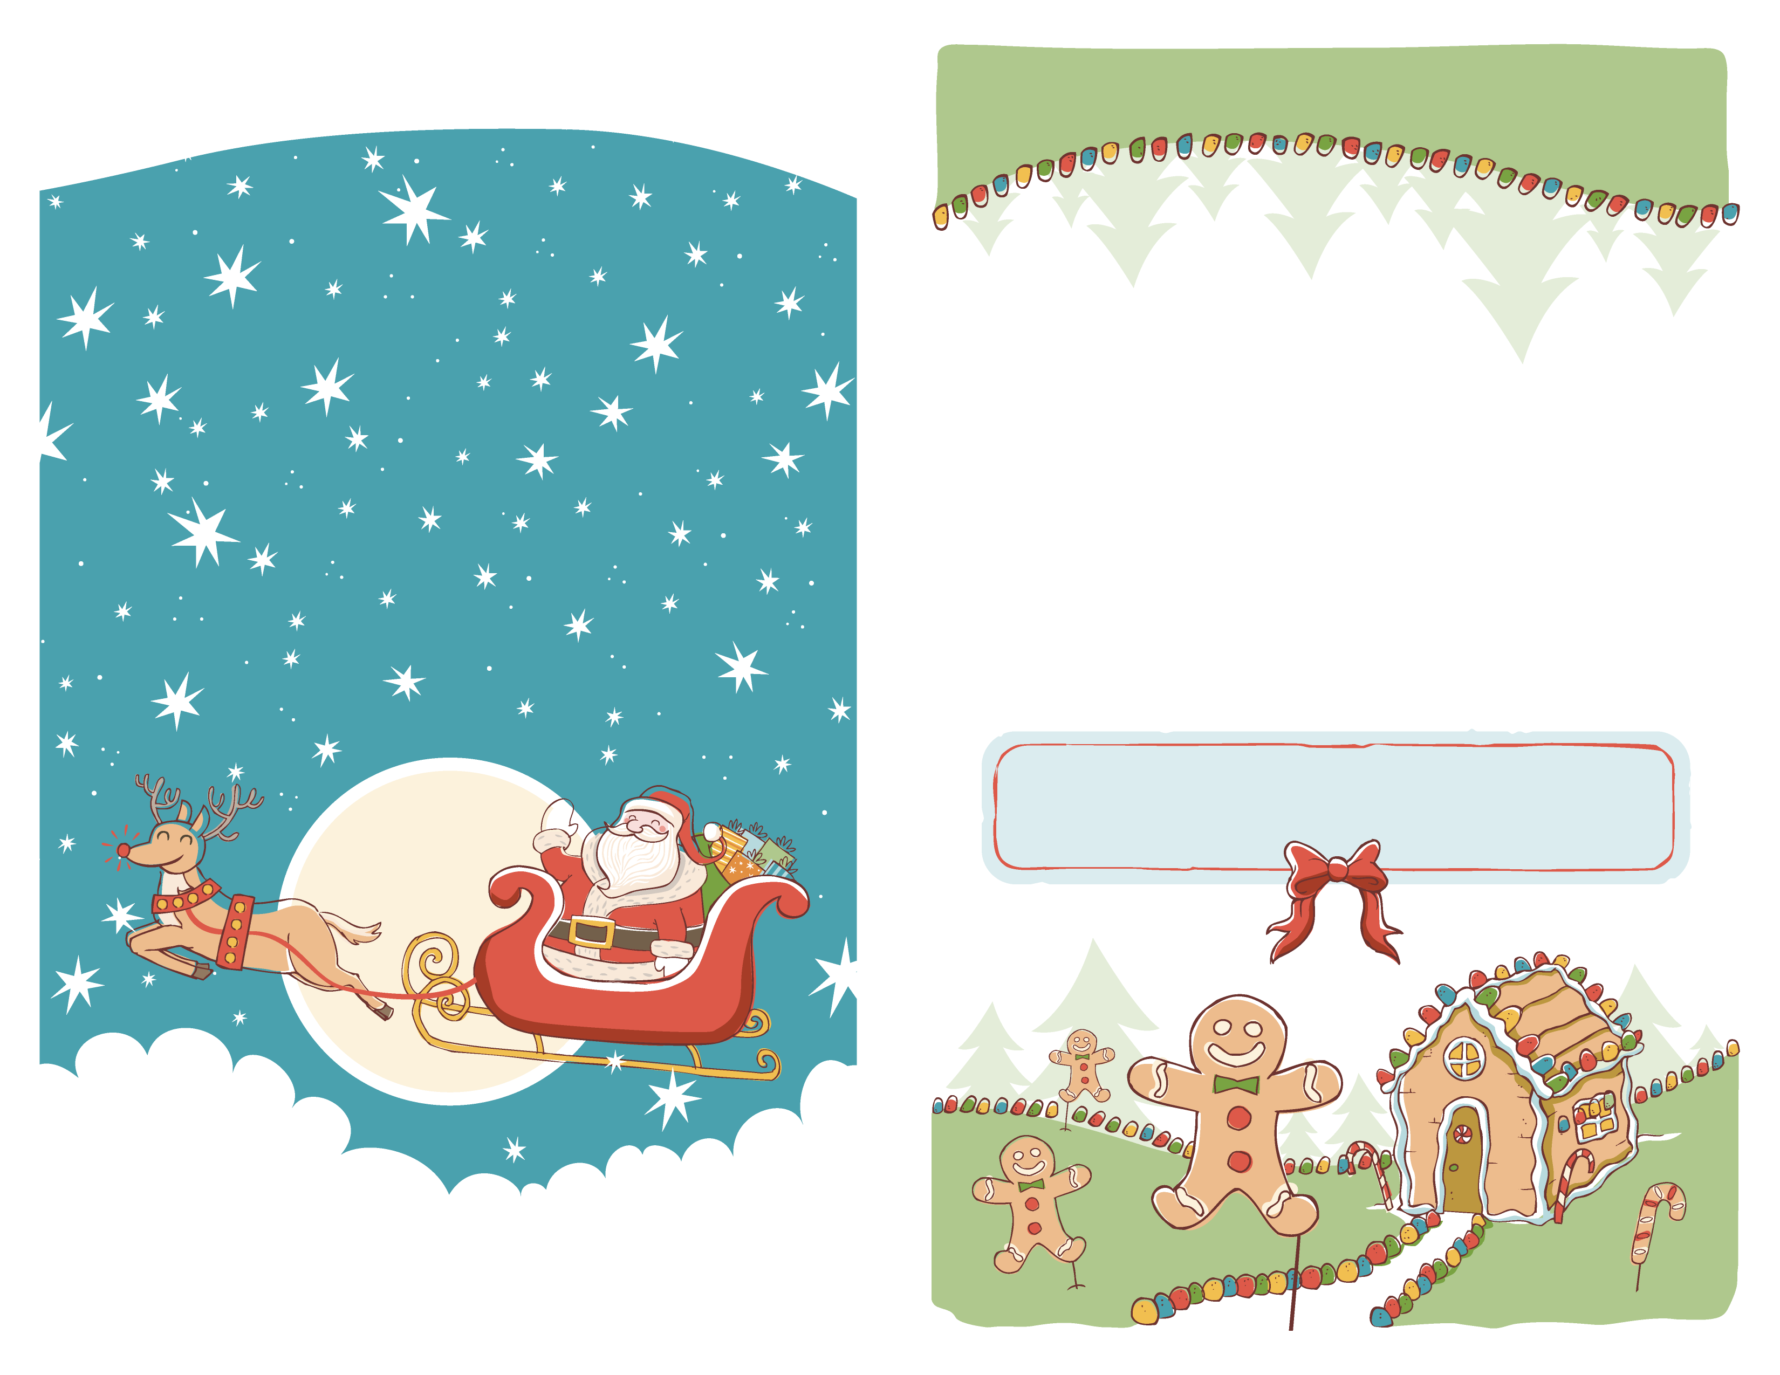
Best wishes for the happiest of holidays! |  |  | Best wishes for the happiest of holidays!
