|  |  |  |  |  |
| --- | --- | --- | --- | --- |
|  | BREAKFAST | LUNCH | DINNER | SNACK |
| SUNDAY |  |  |  |  |
| MONDAY |  |  |  |  |
| TUESDAY |  |  |  |  |
| WEDNESDAY |  |  |  |  |
| THURSDAY |  |  |  |  |
| FRIDAY |  |  |  |  |
| SATURDAY |  |  |  |  |
|  |  |  | Made in Office 2007 for office2007.com |  |

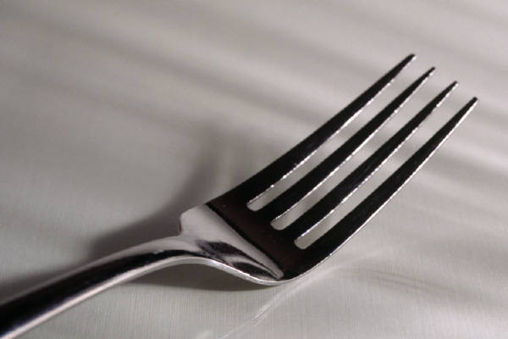

WEEKLY MEAL PLANNER